Performance Testing

Date | November 2, 2025
Team ID | F53C03230D9D3649CD4402B24FF15FEB
project Name | Educational organization using ServiceNow

Project: Educational Management System Using ServiceNow
1. Objectives:
- To verify that all functional requirements are met (calculations, auto-population).
- To ensure the application is responsive and meets non-functional performance requirements.
- To identify and log any bugs or defects before deployment.


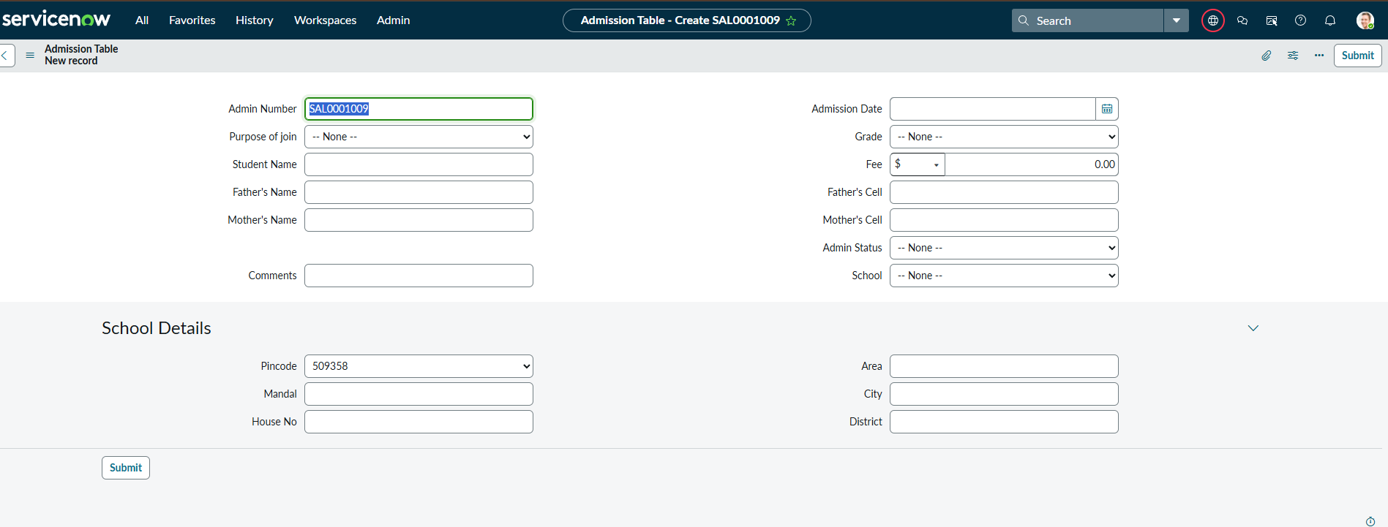
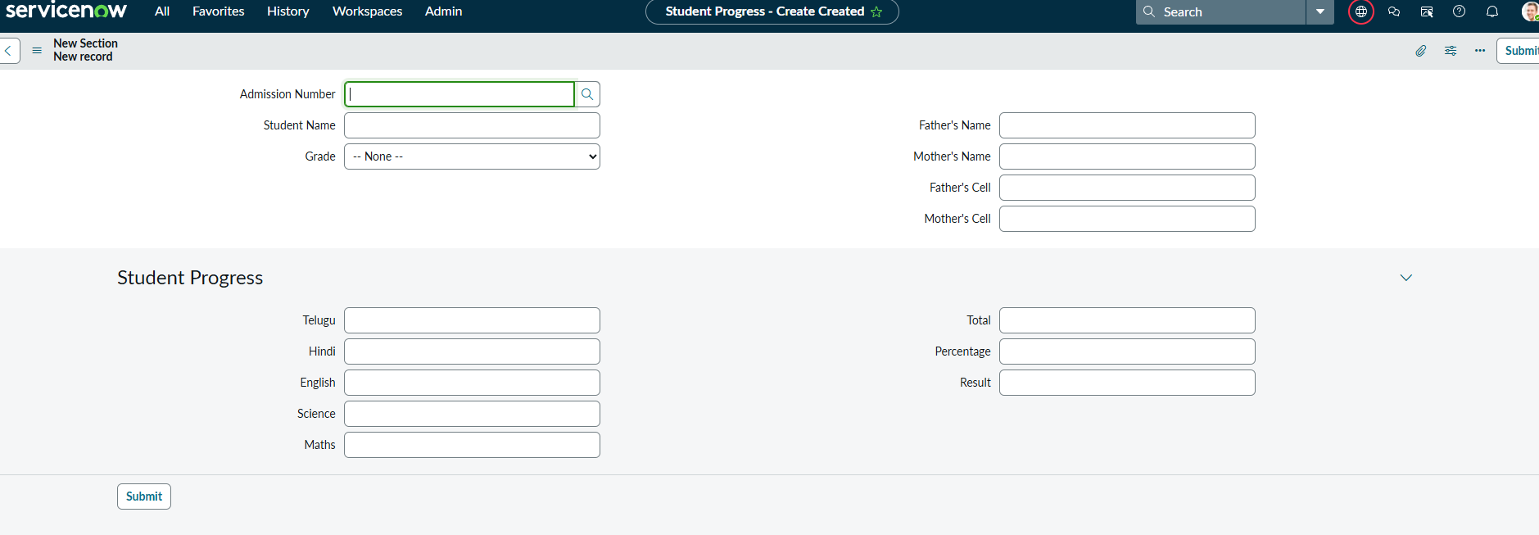
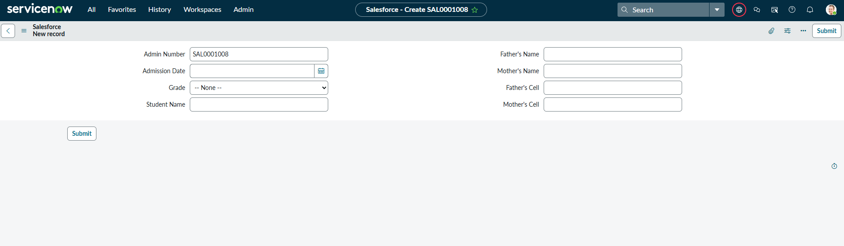

2. Test Cases:
Test Case ID | Feature | Test Steps | Expected Result | Actual Result | Pass/Fail
TC-01 | Form Load | 1. Navigate to "Admission" > "New".  2. Time how long the form takes to load. | Form should be interactive in < 3 seconds.
TC-02 | Pincode Script | 1. On the Admission form, go to the "Pincode" field.  2. Enter "509358".  3. Tab out of the field. | "Mandal," "City," and "District" fields instantly populate with "kadthal," "kadthal," and "RangaReddy."
TC-03 | Number Maintenance | 1. Fill out and save a new "Admission" record.  2. Open the new record.  3. Check the "Admin Number" field. | The field is populated with a unique ID starting with "SAL" (e.g., "SAL0000001").
TC-04 | onLoad Script | 1. Navigate to "Student Progress" > "New".  2. Observe the form. | The Total, Percentage, and Result fields are all grayed out (read-only).
TC-05 | Calculation Chain | 1. On the "Student Progress" form, enter "70" into all 6 subject fields.  2. Observe the calculation fields. | - Total updates to "420".<Mbr>- Percentage updates to "70%".  - Result updates to "Pass".
TC-06 | Result: Fail | 1. On the "Student Progress" form, change all marks to "50".  2. Observe the calculation fields. | - Total updates to "300".  - Percentage updates to "50%".  - Result updates to "Fail".
TC-07 | Auto-Populate | 1. On the "Student Progress" form, select an existing student in the "Admission Number" field. | The student's "Student Name," "Father Name," etc., auto-populate on the form.
TC-08 | Error Handling | 1. On the "Student Progress" form, manually force the Percentage to "110" (using a separate script).  2. Trigger the "Result" script. | An error message "Percentage should be between 0 and 100" appears. The Result field is cleared.

